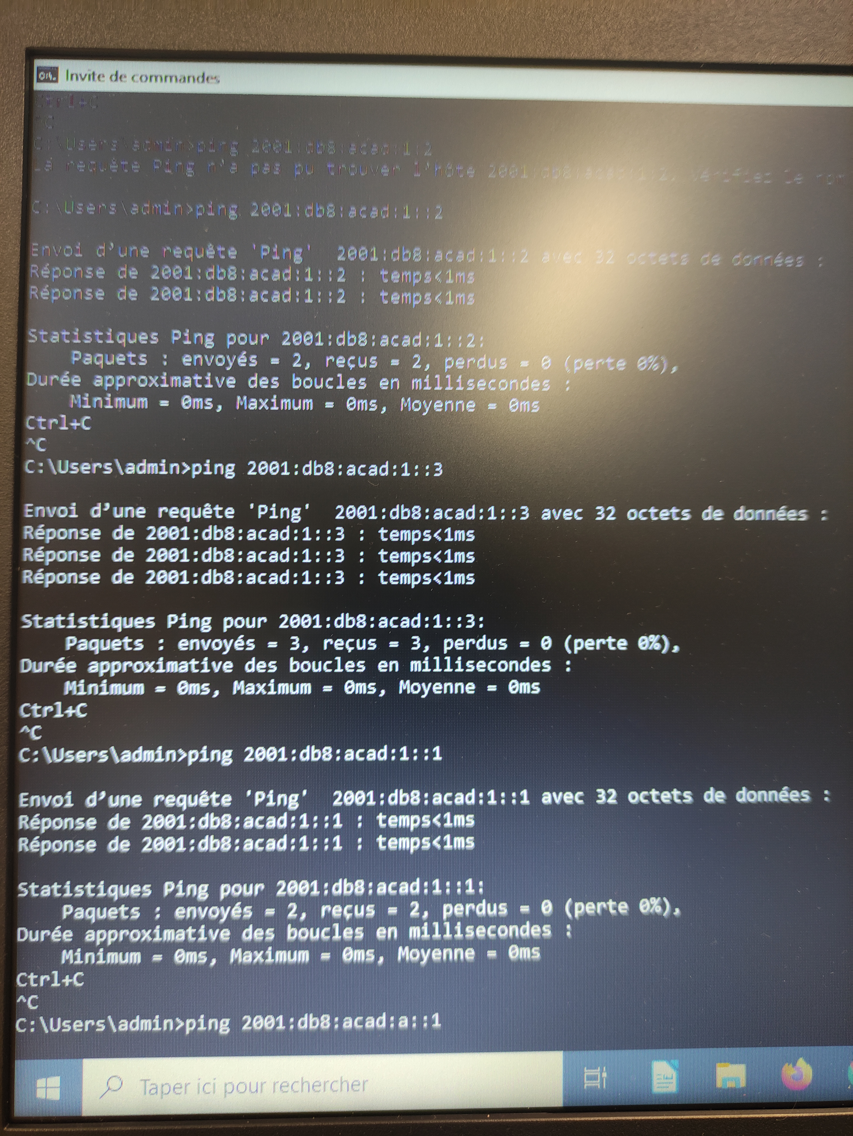
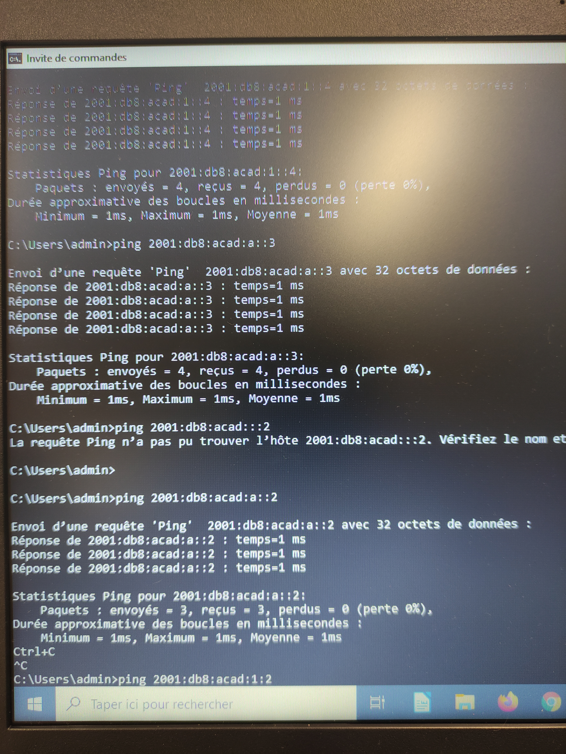
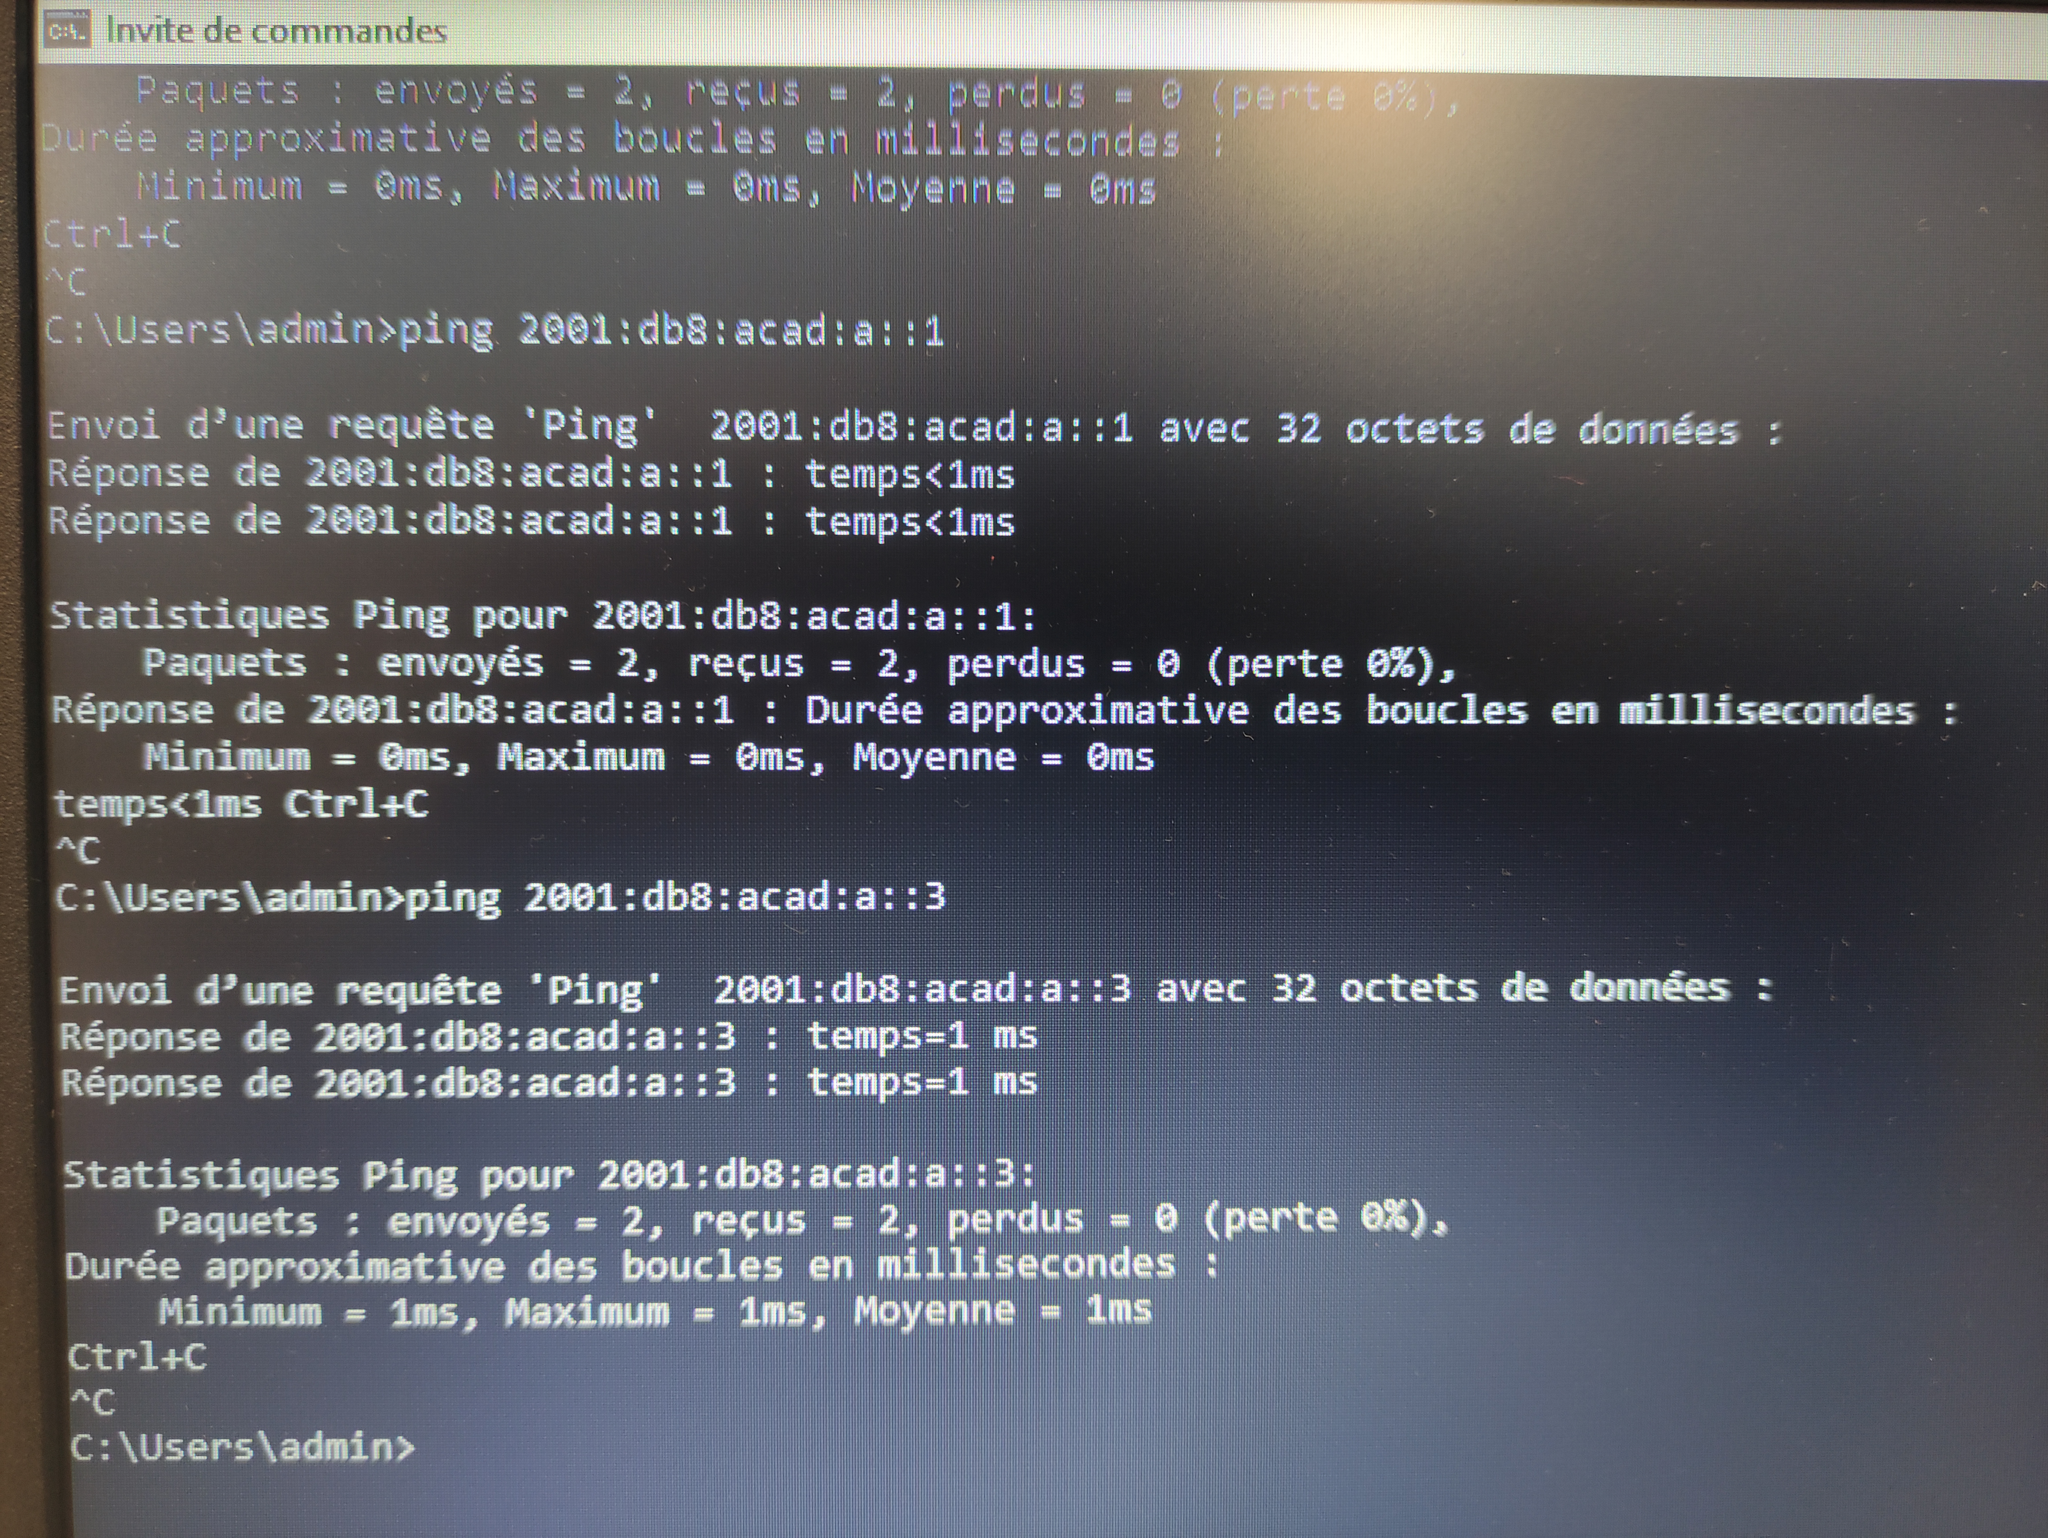
R1#conf t
R1(config)#ipv6 unicast-routing
R1(config)#interface gigabitEthernet 0/0
R1(config-if)#ipv6 address 2001:db8:acad:a::1/64
R1(config-if)#ipv6 address fe80::1 link-local
R1(config-if)#no shut
R1(config-if)#exit
R1(config)#interface gigabitEthernet 0/1
R1(config-if)#ipv6 address 2001:db8:acad:1::1/64
R1(config-if)#ipv6 address fe80::1 link-local
R1(config-if)#no shut
R1(config-if)#exit
R1(config)#do show ipv6 interface brief

SW1#conf t
SW1(config)#sdm prefer dual-ipv4-and-ipv6 default
SW1(config)#exit
SW1#reload
SW1(config)#interface vlan1
SW1(config)#ipv6 address 2001:db8:acad:1::2/64 (ou 2001:db8:acad:a::2/64 pour le deuxième)
SW1(config)#no shut
SW1(config)#exit
SW1#exit
SW1#show ipv6 interface vlan1

